AM420 – Aerodynamics
Flow past a Right Circular Cylinder

(Revised by G. Dewar for ELD Wind Tunnel - Sep. 2000)

- Introduction

The flow normal to a circular cylinder is “canonical” in that it is a simple fluid dynamic system, which may represent flow past nearly any non-streamlined body. The flow presents some interesting features, including boundary layer separation and vortex shedding. In this laboratory, we will measure average pressures and visually observe streamlines for flow over a cylinder. We will compare the measurements to the values generated by potential flow theory.

- Laboratory Information

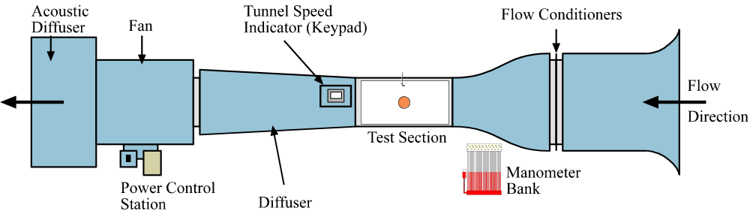

Figure 1: Low Speed Wind Tunnel.

The purpose of this lab is to investigate the pressure profile on the surface of a right circular cylinder for a set Reynolds number (Re_{D}=U∞D/v) and compare the results to those predicted from potential flow theory. The experiment will be carried out in the low speed wind tunnel (see Figure 1), at Reynolds numbers given by the TF.
The low speed wind tunnel is fitted with a 2-inch diameter cylinder in its 18-inch by 18-inch test section. The cylinder has 10 pressure taps around its circumference at 20º intervals, the positions of which can be controlled by rotation of the cylinder within its housing. These pressure taps are connected via tubing to a pressure transducer and digital readout assembly. A Pitot probe (measuring P_{T}) and static tap (measuring 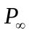) are installed in the wind tunnel to determine the freestream velocity.
The digital readout assembly is connected to a PC for retrieval of the data (see Figure 2). A LabVIEW program will be used to carry out the experiment. The program will collect differential pressures 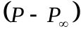 for each port (1 through 18, corresponding to angles 0º through 340º at 20º intervals) and Pitot-static pressure 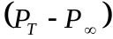 at the designated Reynolds number. The speed of the tunnel is set by the computer using the Reynolds number the user inputs at the start of the program, as described in part 4 of this report.

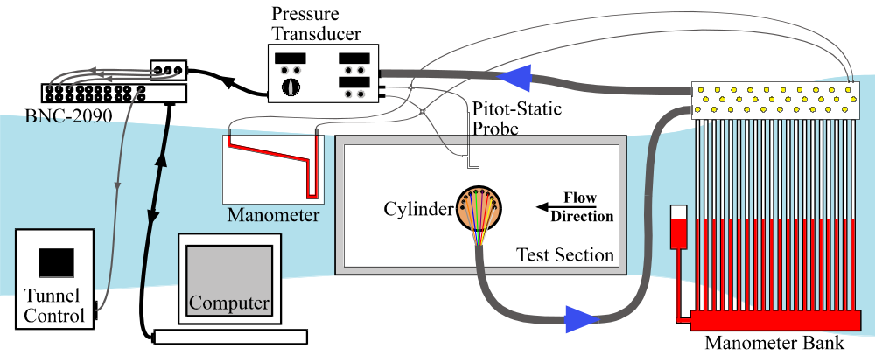

Figure 2: Experimental Setup for Tunnel Test Section

To read the pressure at each port turn the dial on the digital readout assembly to the appropriate port number. Port ‘0’ reads the Pitot- static pressure , while ports ‘1’ through ‘9’ reads the differential pressure on the cylinder surface, with port ‘1’ corresponding to the upstream edge of the cylinder when it is set at 0º. The pressures can also be obtained manually from the manometer bank attached to the cylinder pressure ports. Valves above the manometer bank allow readings to be taken by either the pressure transducer or the manometer bank. The coordinate system used for the cylinder can be seen in Figure 3.

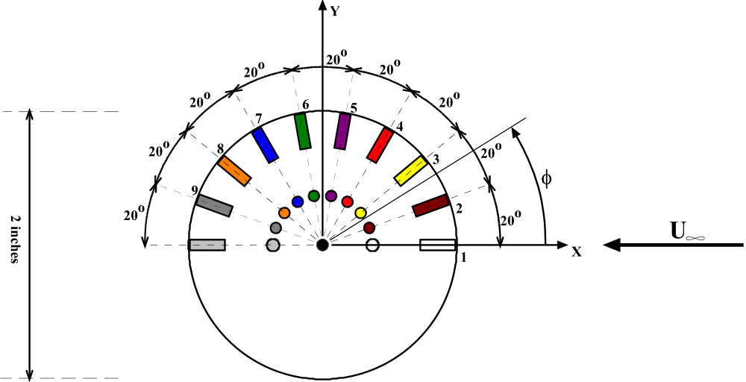

Figure 3: Coordinate system for Cylinder.
- Theory

  - Potential Flow Theory

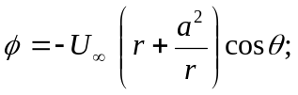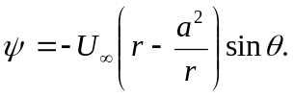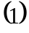Potential flow theory (which assumes inviscid irrotational two-dimensional flow) may be used to predict the flow over a cylinder. Superimposing a doublet (a source-sink combination) with a uniform flow yields the following velocity potential, φ, and the stream function, ψ, representing flow with freestream velocity 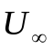from right to left over a cylinder of radius ‘a’:

Note that in this coordinate system θ is 0º at the leading edge (upstream) of the cylinder and r = 0 at the cylinder centerline.
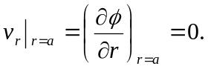 The velocity at any point on the surface of the cylinder is purely tangential:
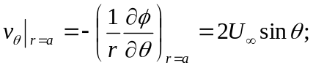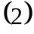
The tangential velocity is zero at θ = 0º and θ = 180º, corresponding to the upstream stagnation point and downstream stagnation point of the cylinder, respectively. Applying Bernoulli’s equation along a streamline from far upstream, the pressure on the surface of the cylinder is:
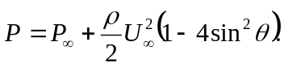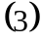
The drag force due to pressure acting on the cylinder is the horizontal component of force per unit area (Pcosθ) integrated over the whole surface area of the cylinder (length L):

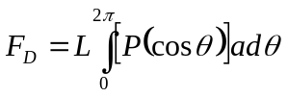 (4)

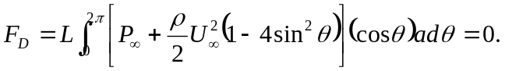 (5)

Thus, potential flow predicts no drag on the cylinder due to pressure. Of course, potential flow also predicts no viscous drag since potential flow by definition is inviscid.

  - Pressure Drag Calculations for Viscous Flow

In real fluids, cylinders exhibit drag. Bertin & Smith describe the flow over a cylinder in detail in section 3.13 {Bertin and Smith, Aerodynamics for Engineers, Third Edition, Prentice-Hall, 1998}. Viscous boundary layers – laminar (or turbulent, depending on the Reynolds number) – form on the surface of the cylinder. The boundary layers separate due to the strong adverse pressure gradient. The wake of the cylinder is characterized by vortices, which shed periodically from the cylinder. The pressure within the separated zone is no longer the pressure predicted by potential flow theory, and a net force due to pressure exists.
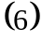 For a broad range of Reynolds numbers the Strouhal number associated with vortex shedding is constant, approximately 0.2. The Strouhal number ‘St’ is defined as:
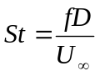
Where f is the vortex shedding frequency, D is the cylinder diameter, and 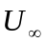is the freestream velocity. The freestream velocity can be calculated from the differential pressure, where 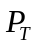 is the total pressure measured by the Pitot probe, and 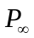 is the static pressure measured from the static tap. From Bernoulli’s equation, the freestream velocity can then be found:
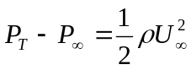 (7)

The non-dimensional pressure coefficient can be calculated for each angle from the following equation, where 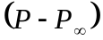 corresponds to the pressure difference from the surface pressure to the static pressure:
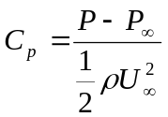 (8)

The pressures on the surface of the cylinder can then be numerically integrated to determine the resultant drag on the cylinder. To numerically integrate, consider equation (4) discretized using ‘N’ pressure ports:

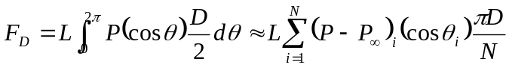 (9)

Similarly;
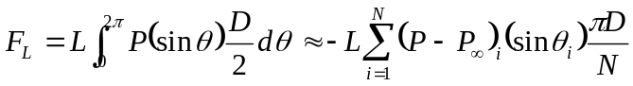 (10)

The drag coefficient for the cylinder can then be calculated. Recall that the drag coefficient is defined as:
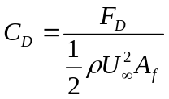 (11)

where A_{f} is the frontal area, in this case (LD). Similarly, the lift coefficient is;

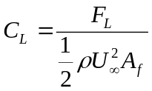 (12)

- Experimental Procedure

  - Smoke Tunnel

In the first part of the experiment, the teaching fellow will place a circular cylinder in the smoke tunnel. Observe the separation of the boundary layers on the cylinder, noting the location of separation. Observe the wake of the cylinder and the vortex shedding frequency’s dependence on the velocity. If you assume that the Strouhal number is 0.2, can you use the shedding frequency to determine the velocity, and thus the Reynolds number? Calculate the Reynolds Number for this case.
The flow over the surface of an airfoil shall also be demonstrated at this time. This demonstration will be important for labs 2 and 3. Sketch your observations for each case.

Low-Speed Wind Tunnel

  - Transducer Calibration

- Place cylinder in tunnel and attach all pressure ports to the manometer bank.

- Position tip of pitot-static probe at the inlet of the test section near the upper wall of the tunnel (Position: X=0m and Y=0.368m on assembly readout). Pitot-static probe can be positioned using knobs on pitot probe mount above tunnel.

- Open LabVIEW program ‘Transducer Calibration’, located in AM420\Lab 1 folder.

- Input required information into LabVIEW program (i.e. date, group number and temperature).

- Start Program by ‘left clicking’ on the play button () at the top left of the LabVIEW control panel screen.

- Hit ‘CONTINUE’ button to set tunnel to required speed (the input voltage corresponding to each calibration speed is indicated in the program).

- Once the tunnel speed has reached steady state (i.e. when indicator on tunnel readout and reading on the inclined manometer have reached constant value) read height (in inches of water) corresponding to dynamic pressure in tunnel.

- Input manometer reading into program.

- Hit ‘TAKE READING’ button to read voltage data from pressure transducer (Note: for each reading the average value from 10000 samples is automatically recorded).

- Repeat steps vi through ix for each required tunnel speed. The program will perform both an incremental and decremental sequence to check for hysteresis.

- On completion of program, results will be sent to the file location indicated in the LabVIEW program. Output file will include height and output voltage information.

- Once all data has been taken, the tunnel will automatically power down.

- Close the valves at the back of the inclined manometer.

- Note down values for ‘Slope’ and ‘Intercept’ from LabVIEW linear curve-fit. The calibration data information shall be required to carry out the experiment.

Note: The Pressure can then be calculated from the transducer voltage using the equation:

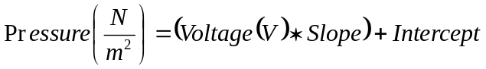 (13)

4.3 Cylinder Pressure Measurements

WARNING: Do not open tunnel test section if cylinder is in tunnel!

WARNING: Do not turn the cylinder by grabbing on to the attached tubes. Use the handles provided!

WARNING: Failure to set transducer to correct position will ruin experiment.

- Open Labview program ‘Cylinder(pressure)’ from the Am420\Lab 1 folder.

- Input required information into 'INPUTS' panel.

- Input Calibration data for pressure transducer and tunnel speed indicator.

- Make sure Pressure Selector on Digital Readout Assembly is set to port '0'. (Note: this gives the Pitot Probe reading)

- Make sure Pitot Probe is positioned correctly (i.e. X = 0m, Y = 0.368m on readout assembly).

- Place cylinder in 0 deg position, corresponding to the red mark on the cylinder housing.

- Left click 'Play' button (top left of screen) to start program.

- Left click on 'START TUNNEL' button to turn tunnel on.

- Wait until tunnel has reached steady state (i.e. Output frequency reading on Tunnel Speed Indicator is constant).

WARNING: Failure to wait until the tunnel has reached steady state will result in bad results!

- Left click on 'CALIBRATE SPEED' button to set tunnel to speed corresponding to required Reynolds number.

- Wait until tunnel has again reached steady state.

- Open valves to manometer tubes 1 through 9 on the manometer bank.

- Compare the pressure distribution indicated on the manometer bank to that predicted by the potential flow equations. (Note: the manometer shows only the distribution over one half of the cylinder at a time). Note down these values on the attached data sheet.

- Close the valves to the manometer tubes, leaving open the path to the pressure transducer.

- Left click on 'TAKE READING' button to read differential pressure from pressure transducer for port '0'.

- Spot check: After taking the Pitot Probe reading (port '0'), check that the measured differential pressure corresponds to the Reynolds number input using Bernoulli's equation and the Reynolds number equation.

- Turn Pressure Selector to port '1'.

- Left click on 'TAKE READING' button to read differential pressure for port '1' (corresponding to the 0 deg angle on the cylinder).

- Repeat steps xvii and xviii for ports '2' through '9' (corresponding to angles 20 through 160 degs on cylinder).

- Turn cylinder counter-clockwise by 180 degs.

- Turn Pressure Selector dial on Digital Readout Assembly to port '1'.

- Open valves to manometer tubes 1 through 9 on the manometer bank.

- Again, note down the values from the manometer bank on the attached data sheet. These values correspond to readings 10 through 18.

- Close the valves to the manometer tubes, leaving open the path to the pressure transducer.

- Take readings 10 through 18 (corresponding to angles 180 through 340 degs) by again repeating steps xvii and xviii for ports '1' through '9'.

- On completion of program tunnel will turn off automatically.

- Output Data (port number and corresponding transducer voltage) will be sent to the file indicated in the 'OUTPUTS' panel. (Note: remember that port number '0’ corresponds to the Pitot static probe reading).

- Repeat program for second Reynolds number.

- Required Calculations & Analysis

- Discuss any observations made from the Smoke Tunnel demonstration for the cylinder. Include a sketch of your observations.

- Plot Differential Pressure versus Voltage for the pressure transducer calibration. Include the linear curve-fit to this data on the plot and state the slope and intercept values for the curve-fit.

- For each Reynolds number, calculate the differential pressure and non-dimensional pressure coefficient, C_{P}, predicted by potential flow theory at each angle.

- For each Re, calculate the differential pressure and non-dimensional pressure coefficient, C_{P}, from the experimental data at each angle.

- Tabulate the calculated differential pressure and C_{P} values for both potential flow theory and the experimental data.

- On a single graph, plot the Differential Pressure versus the Angle for both potential flow theory and the experimental data.

- On a single graph, Plot C_{P} versus angle for both potential flow theory and the experimental data.

- Discuss any similarities or differences in the curves.

- For each Re, calculate F_{D} and F_{L} using the given discretized equations.

- For each Re, calculate C_{D} and C_{L}. Comment on these results.

- Tabulate Re, velocity, F_{D}, C_{D}, F_{L}, C_{L}.

- Question: Drag consists of viscous drag and pressure drag. The experiment measures only pressure drag. Comment on your results based on this.

- Laboratory Report Format

The purpose of this lab is not only to apply your understanding of aerodynamics to a simple experiment but also to give you practice in communicating your findings. As such, the quality of the writing will be evaluated in terms of grammar, spelling, clarity, organization and legibility of figures and tables. The report should be understandable by someone who is not necessarily familiar with the specifics of the lab. The quality of the writing will count for a portion of your grade.
Reports must be typed, double-spaced with suitable margins. Please use only one side of the page, normal white paper; forgo fancy covers. The following format is required for the organization of the report:

- Title page
- Introduction
- Theory and Methods
- Results and Analysis
- Discussion and Conclusions
- Appendices (e.g. data, sample calculations)

The Title page should include the title of the lab, the names of all members of the lab group, as well as the date on which the lab was performed. Please make this a separate page.
The Introduction section should briefly state in your own words what you are trying to do and why you are doing the experiment. Do not simply copy or paraphrase the appropriate sections of the lab handout.
The section on Theory and Methods should explain the relevant theory, measurement techniques, and procedures for the lab. Please be complete and sufficiently detailed for someone who has not performed the lab to be able to understand it. Derivations of equations used in your analysis are appropriate. Again, do not simply copy or paraphrase the appropriate sections of the lab handout.
In the Results and Analysis section, you should summarize and explain the results of the experiment, including charts and graphs. Graphs should be plotted to best show the information gained from the experiments, i.e. use linear or log scaling where appropriate, plot experimental data as individual points and theoretical and computational data as continuous lines, and make sure all axes and data curves are clearly labeled. This section should be strictly factual, pointing out agreement and discrepancies between your results and those predicted by theory. All numerical results should be non-dimensional or reported in SI units. This is where most of the items you calculate and plot in the ‘Required Calculations and Analysis’ section should go. (Note: all tables and graphs should be referenced and explained in the body of the text).
For the Discussion and Conclusions, examine whether the lab satisfies the stated purpose, explaining what you have learned. Also postulate why any differences might have arisen between the theoretical (or standard experimental) values and your own results.
The Appendices should contain relevant information that is not in the body of the lab report, such as the original data sheets and details of calculations made both in lab and as part of your data analysis. Sample calculations should either be typeset or neatly written in ink.
If you rely on information from textbooks or other references, cite the references in appropriate bibliographical style. Quoting references without citing sources is plagiarism.

Data Sheet

Room Temperature (ºF) | 1: | 2:

Reynolds Number | 1: | 2:

Manometer Bank Readings:

Reading | 1: Height (inches) | 2: Height (inches)
1
2
3
4
5
6
7
8
9
10
11
12
13
14
15
16
17
18
Static
Total

Output File Locations:

Calibration Data
Cylinder Data | 1:
Cylinder Data | 2:

